Docker Tutorial Series

Unless you have intentionally decided to block any news around software in your social feeds, it is likely that you have heard about [Docker](https://www.docker.com/).

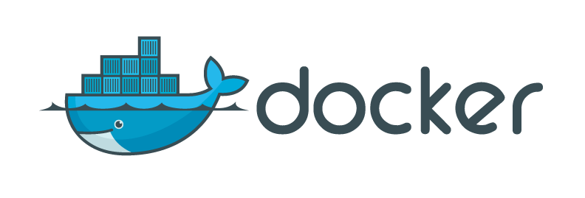

* [Part 1 — Installation](http://rominirani.com/2015/07/19/docker-tutorial-series-part-1-installation/)
* [Part 2 — Basic Commands](http://rominirani.com/2015/07/19/docker-tutorial-series-part-2-basic-commands/)
* [Part 3 — More on Images and Containers](http://rominirani.com/2015/07/19/docker-tutorial-series-part-3-more-on-images-and-containers/)
* [Part 4 — Docker Hub](http://rominirani.com/2015/07/19/docker-tutorial-series-part-4-docker-hub/)
* [Part 5 — Building your own Docker Images](http://rominirani.com/2015/07/26/docker-tutorial-series-part-5-building-your-own-docker-images/)
* [Part 6 — Docker Private Registry](http://rominirani.com/2015/07/27/docker-tutorial-series-part-6-docker-private-registry/)
* [Part 7 — Data Volumes](http://rominirani.com/2015/07/31/docker-tutorial-series-part-7-data-volumes/)
* [Part 8 — Linking Containers](http://rominirani.com/2015/07/31/docker-tutorial-series-part-8-linking-containers/)
* [Part 9 — Writing a Dockerfile](http://rominirani.com/2015/08/02/docker-tutorial-series-writing-a-dockerfile/)
* [Part 10 — Docker Swarm Tutorial](https://rominirani.com/docker-swarm-tutorial-b67470cf8872#.w007jor4i)
* [Part 11 — Docker Swarm on Google Compute Engine](https://rominirani.com/docker-swarm-on-google-compute-engine-364765b400ed#.d9d69reze)
* [Part 12 — Getting Started with Kubernetes using Minikube](https://rominirani.com/tutorial-getting-started-with-kubernetes-on-your-windows-laptop-with-minikube-3269b54a226#.b03rkiadr)
* [Part 13 — Docker Management Commands](https://rominirani.com/docker-management-commands-e89a23c55908#.per2vrbnm)
* Appendix
* [Docker : Learning Resources](http://rominirani.com/2015/07/31/docker-learning-resources/)
* [Docker Use Cases](http://rominirani.com/2015/04/09/docker-use-cases/)
* [Learning Docker ? Move To The Cloud !](http://rominirani.com/2015/03/16/learning-docker-move-to-the-cloud/)